
PDAN8412 POE Part 3

November 21, 2025
Allana Morris
ST10204772

Table of Contents
Table of Figures 3
Dataset Evaluation and Justification 4
Analysis Planning 6
Exploratory Data Analysis (EDA) 6
Examine raw images for visual properties 6
Verify label accuracy 6
Verify image dimensions and aspect ratios 6
Validate colour channels and pixel ranges 7
Analyse character frequency distribution 7
Inspect pixel intensity and contrast distributions 7
Review edge cases and ambiguous examples 7
Feature Selection 8
Emphasis on Automated Convolutional Feature Extraction 8
Standardization of Input Dimensions 8
Normalization of Pixel Values 8
Controlled Data Augmentation for Variability Enhancement 9
Preservation of Spatial Relationships in Preprocessing 9
Compatibility with Multi-Output Prediction Tasks 9
Targeted Augmentation for Underrepresented or Ambiguous Classes 9
Preprocessing Approaches Preserving Character Legibility 9
Model Training 10
Determination of Convolutional Depth for Hierarchical Feature Learning 10
Selection of Kernel Sizes for Fine-Grained Feature Capture 10
Application of Max Pooling for Dimensionality Reduction and Translation Invariance 10
Implementation of Batch Normalization for Training Stability 10
Regularization via Dropout to Mitigate Overfitting 11
Employment of the Adam Optimizer for Adaptive Learning Rate Control 11
Strategic Learning Rate Scheduling 11
Application of Sparse Categorical Cross-Entropy Loss for Multi-Class Output 11
Early Stopping Based on Validation Performance 11
Checkpointing for Model State Preservation 12
Systematic Hyperparameter Optimization 12
Interpret and Evaluate Model 12
Monitoring Learning Curves Across Training and Validation 12
Character-Level and Positional Performance Metrics 12
Assessment of Full CAPTCHA Sequence Accuracy 13
Confusion Matrix Analysis by Character Position 13
Evaluation of Precision, Recall, and Class-Specific Performance 13
Qualitative Inspection of Correct and Incorrect Predictions 13
Robustness Assessment Under Distortion and Noise Conditions 13
Analysis of Predictive Confidence and Reliability 13
Report Writing 14
Documentation of Dataset Provenance and Preprocessing Protocols 14
Presentation of EDA Findings Using Quantitative and Visual Evidence 14
Detailed Description of CNN Architecture and Training Regimen 14
Comprehensive Reporting of Evaluation Metrics and Qualitative Examples 15
Rationale and Methodology of Hyperparameter Selection 15
Discussion of Limitations, Constraints, and Ethical Considerations 15
Recommendations for Future Research Directions 15
Model Evaluation 16
Report 21
Introduction 21
Data Cleaning and Preparation 22
Exploratory Data Analysis 22
Model Training 24
Model Evaluation 24
Conclusion 25
Reference List 26

Table of Figures
Figure 1: Examples of Different Text-based CAPTCHAS (Segovia, 2016) 4
Figure 2: Bar Graph displaying the Final Performance Metrics of the model 16
Figure 3: Line graph displaying the change in Training and Validation Losses over each Epoch 17
Figure 4: Confusion Matrix displaying the Model's misclassification count per character 18
Figure 5: Bar Graph displaying Accuracy for each Character position in the CAPTCHAs 19
Figure 6: Sample Images of correctly predicted CAPTCHAS with Character Highlighting 19
Figure 7: Sample Images of Incorrectly predicted CAPTCHAS with Character Highlighting 20
Figure 8: Sample of raw CAPTCHA Images 23
Figure 9: Bar Graph Displaying Character Frequency throughout dataset 23

Dataset Evaluation and Justification
The dataset selected for this research work is a large collection of six-character CAPTCHA images representing alphanumeric symbols under varied and visually complicated conditions. A critical evaluation of the dataset has been performed, which showed that this dataset is appropriate for the proposed Convolutional Neural Network model, mainly due to its visual characteristics, scale, label integrity, and alignment with real world CAPTCHA challenges.
The first dimension of suitability concerns the visual and spatial complexity of the images. CAPTCHA systems intentionally incorporate noise, irregular line patterns, distortions, warping, colour variation, non-uniform spacing, and background artefacts to obscure character boundaries. These same complexities make the dataset suitable for deep learning because Convolutional Neural Networks are specifically designed to extract hierarchical spatial features from grid-structured data (Lecun, Bengio and Hinton, 2015). CAPTCHA images provide rich pixel-level variation that supports the learning of edges, curves, and structural character patterns. The wide range of distortions and transformations present in the data simulates real-world conditions for CAPTCHAs, as such strengthening the dataset's appropriateness for a CNN model dependent on spatial pattern recognition (Goodfellow, Bengio and Courville, 2016).

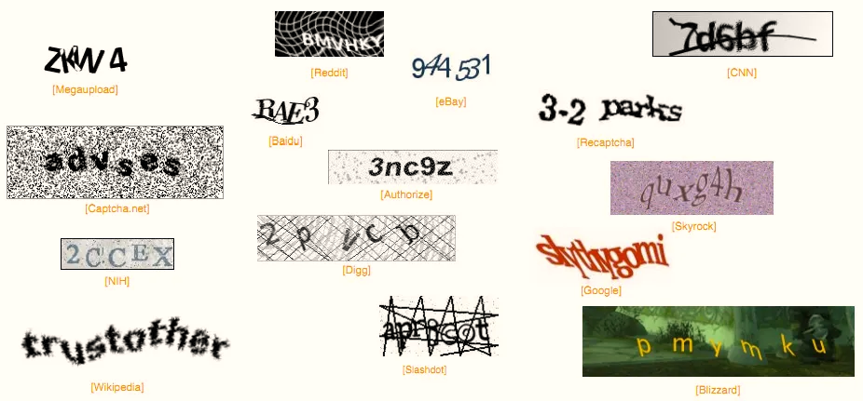
Figure 1: Examples of Different Text-based CAPTCHAS (Segovia, 2016)

A second factor supporting suitability refers to the dataset's diversity and scale. High performing CNN models require large and varied datasets, so that learned features generalize across different representations of the same class. The dataset in this study contains thousands of samples with extensive variation in character shape, noise density, font style, brightness, colour and geometric distortion. This variety supports the model's ability to learn invariant representations and reduces the likelihood of overfitting. As it has been argued, datasets characterized by broad intra-class variation enhance deep learning performance because they force the model to develop more flexible and robust features (Sun et al., 2017). An additional value is brought about by the presence of character pairs that are often visually confused, such as O and zero or I and one, challenging the model to learn fine-grained distinctions-a task for which CNNs are well-suited (Rawat and Wang, 2017).
A third aspect of assessment includes data quality and the reliability of the assigned labels. Every image in this dataset contains exactly six characters, and the label is reliably encoded in the filename. This provides a direct and reliable association between every image and its ground truth sequence. High-quality labels are of utmost importance in supervised learning since any inconsistency or inaccuracy in the labels can decrease training stability and lower model performance. Frénay and Verleysen (2014) argue that the dataset shows strong structural consistency, with images stored in a uniform format, uncorrupted, and compatible with standard preprocessing operations like resizing and pixel normalization. This clarity and reliability in structure support consistent data loading and transformation processes that are fundamental to effective model training.
A fourth consideration is the authenticity of the distortions and artefacts present in the dataset. CAPTCHA systems are purposely designed to prevent automated detection through visual obfuscation techniques. The dataset realistically mirrors these real world characteristics through the inclusion of noise patterns, overlapping lines, irregular backgrounds and unpredictable character spacing. Training on distorted and difficult images lets the model develop resilience to occlusion and noise qualities that are critical for practical applications of CAPTCHA solving. CNNs have strongly performed time after time in recognition tasks where images contain noise or irregular patterns, or where the subject is partially occluded, such as handwritten digit recognition and object classification (Krizhevsky, Sutskever and Hinton, 2012). The dataset, therefore, provides an appropriate level of complexity for evaluating the model’s capacity to recognise characters in realistic and challenging conditions.

Analysis Planning

Exploratory Data Analysis (EDA)
Before any modelling is done, the Exploratory Data Analysis stage ensures that the CAPTCHA dataset is of good quality, structure, and dependability. Because the CNN is particularly sensitive to inconsistency in input data, each of the following phases is designed with a defined objective and justified justification (Lecun, Bengio and Hinton, 2015).

Examine raw images for visual properties
Directly analysing the raw images is particularly important because one has to know the 'visual properties' of the dataset, such as the noise patterns, distortions, occlusions, background artefacts, colour variations, and font style differences. The visual deceptions are deliberately included within a CAPTCHA system to make automated recognition impossible. Being able to identify all these characteristics ensures that correct decisions on preprocessing, like denoising, normalisation, and augmentation, would be appropriate with respect to the dataset's complexity. CNNs learn from the spatial structure of pixels. Failure to understand this would lead to designing transformations that may inadvertently remove important discriminative information (Goodfellow, Bengio and Courville, 2016).

Verify label accuracy
Supervised deep learning relies exclusively on accurate input-label pairs. In case a label does not correctly reflect the six characters featured in the CAPTCHA image, the model receives contradictory training signals. Label noise has been shown to degrade convergence, reduce classification accuracy, and increase the likelihood of learning unstable or misleading patterns (Frénay and Verleysen, 2014). Commonly, CAPTCHA datasets encode labels in filenames, which are easy to verify. Being sure that each image corresponds with its correct character sequence keeps the integrity of the learning process, especially in a multi-output task where mistakes will multiply across positions.

Verify image dimensions and aspect ratios
This is because CNNs require fixed-size inputs to apply the convolutional kernels consistently across the dataset. Image dimensions may vary and trigger errors during batching; this might also affect the receptive field of filters, which in turn impacts feature detection (Krizhevsky, Sutskever and Hinton, 2012). Dimension checks are important because they assist in establishing whether resizing, padding, or dimension cropping needs to take place. It is incredibly significant to maintain proper image aspect ratios because distorting images due to incorrect resizing has the potential to flatten character shapes, stretch edges, or compress curves and, therefore, may be harder for the model to tell apart. Generally, image dimension consistency is one of the fundamental requirements of pre-processing in CNN-based image classification (Rawat and Wang, 2017).

Validate colour channels and pixel ranges
CAPTCHA images are in RGB. This is so that all the images have a coherent colour format, which helps to ensure that the model will not see structural differences among samples unrelated to their semantic content. The CNN considers each colour channel as an independent feature map. Inconsistency introduces artificial variability. Moreover, the range of pixel intensities across datasets also varies; confirmation of the dynamic range supports decisions about normalisation strategies. Normalization is crucial for numerical stability because large or very skewed pixel values will destabilize gradient descent (Goodfellow, Bengio and Courville, 2016). Consistency in colour format and pixel range ensures the model learns from structural patterns rather than on irrelevant formatting differences.

Analyse character frequency distribution
Class distribution analysis shows how frequently each character in the dataset occurs. There might be a mix of digits and uppercase letters, but their occurrence can be unbalanced in either CAPTCHA dataset. Class imbalance biases the model toward predicting those characters that occur more frequently, hence lowering accuracy on others. Measuring distribution provides insight into whether techniques such as class weighting or targeted augmentation are required. Research on imbalanced classification indicates that models trained on skewed distributions can achieve high overall accuracy but often perform terribly on minority classes (He and Garcia, 2009). Understanding the pattern of distribution is henceforth essential in the design of a fair and reliable model.

Inspect pixel intensity and contrast distributions
Preprocessing such as normalisation, histogram equalisation, or contrast adjustment will be informed by pixel intensity patterns. If there is great variation in brightness or contrast across images, a normalisation strategy will help standardize the data and stabilize model training (Goodfellow, Bengio and Courville, 2016). Knowledge of the amount of variation in contrast informs decisions around which augmentation techniques should be utilized-such as jitter in brightness. Pixel-level histograms and statistical summaries inform whether data have consistent illumination or whether a model must learn to be invariant to different lighting conditions (Shorten and Khoshgoftaar, 2019).

Review edge cases and ambiguous examples
CAPTCHA datasets often include oddly distorted, overlapped, and occluded characters. The early identification of such edge cases shows if the dataset includes representations that are intrinsically difficult both for humans and models to deduce (Sun et al., 2017). A look at such samples will set expectations on the achievable accuracy and will present a need to consider augmentation strategies that simulate difficult conditions. Edge-case analysis also guides decisions on the intensity of preprocessing and helps in the detection of samples that one should avoid because they might be illegible or out of the ordinary when considering standard CAPTCHA formatting.

Feature Selection
The CNN differs from the traditional machine learning feature selection process since a model can automatically learn spatial feature representations directly from raw pixel data. Therefore, the major task should be to guarantee that the data is prepared in a way that allows these convolutional layers to extract meaningful patterns (Lecun, Bengio and Hinton, 2015).

Emphasis on Automated Convolutional Feature Extraction
CNNs are specifically developed to learn hierarchical image features directly from pixel inputs. Early layers typically learn low-level structures like edges, contours, and textures, while deeper layers learn high-level abstractions such as shapes and the structure of the characters (Krizhevsky, Sutskever and Hinton, 2012). By nature, there is no need for manually extracted features, which would involve anything from edge detectors to handcrafted descriptors, because it may limit the representative capacity of the whole model. Allowing CNNs to learn all features decreases human bias, increases model flexibility, and generally brings better performance in image classification tasks (Rawat and Wang, 2017). The use of automated feature extraction is, therefore, the best and theoretically founded option for the recognition of CAPTCHA characters (Lecun, Bengio and Hinton, 2015).

Standardization of Input Dimensions
The model wants all photos to be the same height, breadth, and number of channels. Without scaling, the varying proportions of all of the images would make it difficult to apply convolution kernels uniformly and create batches. Resizing ensures structural uniformity while maintaining semantic content. Since CAPTCHAs may be different in raw resolution, resizing also ensures that receptive fields correspond with comparable pixel regions across images (Goodfellow, Bengio and Courville, 2016). Such consistency is crucial for the learning of meaningful visual patterns, since the model may attribute varying semantic meanings to the same character depending on the size of the input (Rawat and Wang, 2017).

Normalization of Pixel Values
To ensure stable training, pixel values need to lie within the same numeric range. Normalisation changes the scale of the pixel values into a uniform one-usually by division by the maximum value, such as 255, or by performing mean-variance normalisation. This helps avoid exploding or vanishing gradients; the gradient can flow well through several layers, which will assist the convergence speed during training (Goodfellow, Bengio and Courville, 2016). Normalisation decreases the sensitivity of the model to changes in global illumination across the dataset. Without this, identical characters of different brightness may seem unrelated to the model.

Controlled Data Augmentation for Variability Enhancement
CAPTCHA data sets often include intended distortions, rotations, occlusions, and overlapping edges with various noise. While the number of such data may be high, the kind of distortions can be unlimited, and preparing the model for such variability improves generalization (Shorten and Khoshgoftaar, 2019). Various data augmentations like random rotation, translation, brightness adjustment, slight scaling, or addition of noise introduce real-life variability and make the model more robust. Augmentation effectively increases the size of a dataset without necessarily collecting new data. Research indicates that it significantly reduces overfitting, hence improving performance in test cases for image classification tasks (Shorten and Khoshgoftaar, 2019). It is important that augmentation is kept under careful control to avoid unrealistic transformations that violate label semantics.

Preservation of Spatial Relationships in Preprocessing
Recognition of CAPTCHAs relies heavily on spatial relationships. Each character appears in a fixed, ordinal sequence and the model must learn the spatial cues that separate one character from the next (Krizhevsky, Sutskever and Hinton, 2012). Preprocessing must avoid disrupting this structure: too much cropping or horizontal shifting might remove the edges of characters, join them together, or change their positional layout within the image. Since convolutional layers encode local spatial dependencies, preserving the approximate geometry of the input is essential if the features the model learns are to remain valid (Lecun, Bengio and Hinton, 2015).

Compatibility with Multi-Output Prediction Tasks
CAPTCHA recognition involves the prediction of a character sequence, unlike single-label classification tasks. The input features must be able to support the extraction of visual cues relevant to all six character positions simultaneously (Rawat and Wang, 2017). Preprocessing that compresses or distorts parts of the sequence impairs the model's ability to learn position-specific representations. Maintaining consistent character spacing and relative layout ensures the model is provided with sufficient information to predict independently each of the six outputs. This supports a stable multi-output learning process.

Targeted Augmentation for Underrepresented or Ambiguous Classes
Specifically, if EDA indicates that some characters are visually ambiguous or appear less frequently, then targeted augmentation can be employed to increase representation balance. Only augmenting these characters allows the model to learn more robust features without excessively modifying the overall dataset distribution. This is also in line with studies of imbalanced classification, which show that synthetic variability improves minority-class performance and leads to a fairer decision boundary (He and Garcia, 2009).

Preprocessing Approaches Preserving Character Legibility
CAPTCHA images often contain artefacts that are intentionally challenging, and one must also make sure that preprocessing does not remove parts of characters that are essential to recognize them. Aggressiveness in noise reduction or morphological operations may erase strokes or other fine details that can be part of the characters; legibility here ensures that convolutional filters can extract the correct structures during training (Goodfellow, Bengio and Courville, 2016). This prerequisite now underlines moderation in preprocessing: its objective is to stabilize the dataset, not to simplify it in ways that reduce the challenge inherent to the original problem.

Model Training
The model training phase describes how the convolutional neural network is to be built, optimized, and fitted on the CAPTCHA dataset. The performance of CNN is not limited to architecture alone; rather, it does depend on training stability, regularisation, and suitability of hyperparameters (Lecun, Bengio and Hinton, 2015). Each step below has a full justification based on deep learning theory and best practices.

Determination of Convolutional Depth for Hierarchical Feature Learning
The CNN extracts a pattern from an image by processing the images through multiple convolutional layers. Early layers learn simple edges and textures; thus, deeper layers learn more abstract features such as curves, strokes, and combinations of character components (Krizhevsky, Sutskever and Hinton, 2012). According to Lecun, Bengio and Hinton (2015), many CAPTCHA characters contain distortions, overlapping edges, and irregular shapes that require deeper feature hierarchies to recognise successfully. Creating a model with numerous convolutional layers enables the network to capture more complicated structures. However, the depth must be balanced to avoid unnecessary computational cost or overfitting. It means that the architecture should be scaled to the complexity observed during EDA (Rawat and Wang, 2017).

Selection of Kernel Sizes for Fine-Grained Feature Capture
Small kernels, such as 3×3, are immensely popular because they capture fine local patterns and allow progressive complexity within a network built through stacked layers (Goodfellow, Bengio and Courville, 2016). The characters in CAPTCHAs are made of detailed strokes, curves, and intersections that need to be captured in high-resolution, local features. Using smaller kernels lets the model learn subtle differences between visually similar characters since this is critical for accurate recognition. Larger kernels would overly smooth these fine details or blur distinctions needed for classification.

Application of Max Pooling for Dimensionality Reduction and Translation Invariance
Max pooling aims at keeping the most salient activations in each region, striving for the reduction of dimensionality in feature maps (Goodfellow, Bengio and Courville, 2016). Translation invariance is obtained in this operation, which can be useful for characters distorted or otherwise slightly shifted. Moreover, this reduces the computational load of subsequent layers due to a decrease in size. Because the characters often appear with varying alignment in CAPTCHAs, pooling helps in stabilizing representations across spatial variations. Too much pooling risks eliminating important visual details, and thus placement and size of the pooling window must be selected cautiously to preserve discriminative spatial information.

Implementation of Batch Normalization for Training Stability
Batch normalization normalizes the input entering each layer, reducing internal covariate shift, and thus allowing for faster and more stable training (Goodfellow, Bengio and Courville, 2016). It allows higher learning rates, improves gradient flow, and reduces initialization sensitivity. Due to noise and distortion effects, there is much variability in pixel dynamics within a CAPTCHA dataset, making the batch normalisation even more useful to avoid instabilities. Well-normalised activations also improve the robustness of the optimisation process, especially in deeper models where gradient variance tends to accumulate.

Regularization via Dropout to Mitigate Overfitting
Dropout reduces the chance of overfitting by randomly deleting neurones during training (Srivastava et al., 2014). This causes the network to learn redundant and scattered representations rather than output patterns for specific inputs. For CAPTCHA datasets, there are usually character shapes and structural regularities which could easily be memorised by a model without dropout. The use of dropout ensures that the model generalises to unseen CAPTCHA variations, since it cannot rely on any single pathway through the network. This becomes of crucial importance when training on complex datasets comprising artificially generated distortions.

Employment of the Adam Optimizer for Adaptive Learning Rate Control
It finds wide applications due to its adaptive learning rate updates and its efficient handling of noisy gradients (Kingma and Ba, 2014). CAPTCHA images contain many forms of noise, such as random artefacts and distortions that add to gradient variability. Adam helps to stabilize training by adapting learning rates for each parameter, enabling fast convergence while being robust (Goodfellow, Bengio and Courville, 2016). Generally, adaptive optimizers outperform fixed learning rate methods on difficult image tasks where the variance in the training data is high.

Strategic Learning Rate Scheduling
The learning rate is the frequency with which the model updates its weights (Goodfellow, Bengio and Courville, 2016). If it is too high, the model becomes unstable, resulting in divergence; if it is too low, training is sluggish, causing it to remain in suboptimal local minimums. Planning a learning rate from the outset, and perhaps carrying out a learning rate strategy, such as lowering between epochs, allows the model to explore the parameter space early on and refine later. Scheduling enhances convergence behaviour and reduces oscillation around minimum.

Application of Sparse Categorical Cross-Entropy Loss for Multi-Class Output
Recognition of CAPTCHA involves classifying multiple independent characters at each of the six output positions. Sparse categorical cross-entropy is efficient for integer-encoded labels and thus quite common in multi-class classification tasks (Goodfellow, Bengio and Courville, 2016). It measures the difference between the probability distribution a model predicts and the true class label. Using this loss function ensures that the model receives strong gradient signals for the wrong predictions and is able to learn discriminative boundaries between visually similar characters.

Early Stopping Based on Validation Performance
When the validation loss no longer improves, the training is stopped early. This keeps the model from overfitting on the training data (Goodfellow, Bengio and Courville, 2016). The CAPTCHA datasets are significantly distorted, which may lead to overfitting of specific noise patterns if the model is trained for a lengthy duration. Using validation loss as a criterion makes sure that the model will retain generalisation ability. This also limits unnecessary computation and saves the best-performing model weights.

Checkpointing for Model State Preservation
Checkpointing saves model weights at important intervals, typically when validation performance increases. This prevents the loss of progress in case of unexpected interruptions (Goodfellow, Bengio and Courville, 2016). It also guarantees that the final model deployed after training is the one corresponding to the best observed performance, not necessarily the last epoch seen. This will be used to retrieve the most stable version of the model for evaluation and reporting.

Systematic Hyperparameter Optimization
Learning rate, dropout percentage, number of convolutional filters, and batch size are some essential hyperparameters that can be optimised to influence training dynamics (Goodfellow, Bengio and Courville, 2016). This requires systematic adjustment depending on validation results to ensure that the final model is neither underpowered nor unduly complex. Controlled adjustment minimizes overfitting, enhances convergence, and can even give the architecture that will better align with the complexity of the dataset. This follows a typical approach in machine learning, where hyperparameter tuning is intrinsic to model optimisation and proper comparison.

Interpret and Evaluate Model
The model evaluation phase describes the way in which the performance of the convolutional neural network will be measured, interpreted, and understood. The evaluation relies not only on numerical metrics but also on robustness, reliability, and practical applicability (Goodfellow, Bengio and Courville, 2016). Every one of the steps which follow includes detailed reasoning, grounded in deep learning theory and best practice.

Monitoring Learning Curves Across Training and Validation
It is essential to understand how well the model learns by tracking training and validation accuracy and loss throughout the epochs. These curves describe whether the model converges, whether the gradients are stable, and overfitting or underfitting. Learning curve analysis lies at the heart of diagnostics in deep learning and is generally recommended for understanding optimisation behaviour (Goodfellow, Bengio and Courville, 2016). By observing these trends, researchers can identify any problems with the training early on and adjust the hyperparameters or architecture accordingly.

Character-Level and Positional Performance Metrics
CAPTCHA recognition corresponds to a six-character independent prediction problem. Evaluation of accuracy by position will help establish which part of the sequence is more difficult for the model. Such differences may be due to either visual position, the pattern of distortion, or the dataset characteristics (Rawat and Wang, 2017). Per-character analysis will therefore help make sense of whether the model has difficulties with specific symbols or positions, which will inform improvements in architecture or preprocessing.

Assessment of Full CAPTCHA Sequence Accuracy
Full sequence accuracy reflects real-world performance because a CAPTCHA is solved only when all six characters are correctly predicted. Character-level metrics do not capture the compounded errors across the sequence (Goodfellow, Bengio and Courville, 2016). Measuring full sequence accuracy means the evaluation must mirror operational demands and the practical utility of the model for real-world CAPTCHA recognition.

Confusion Matrix Analysis by Character Position
Confusion matrices provide the ability to look in detail at which character classes are being misclassified and commonly confused. CAPTCHAs often contain visually similar symbols; examples include “O” and “0.” Confusion matrices expose these problem areas (Rawat and Wang, 2017). This kind of granularity aids in understanding weaknesses at a specific point and guides improvements in training and dataset augmentation or class balancing.

Evaluation of Precision, Recall, and Class-Specific Performance
Accuracy alone does not distinguish between types of errors, particularly when dealing with an imbalanced dataset. Precision indicates how frequently the predicted characters are correct and recall indicates how effectively the genuine characters are recovered (He and Garcia, 2009). These metrics provide a comprehensive performance overview by summarising prediction quality and consistency across classes.

Qualitative Inspection of Correct and Incorrect Predictions
Visual inspection of predictions can reveal the pattern of errors that may not be obvious through numerical metrics. Misclassifications can occur due to extreme distortion, overlapping shapes, noise interference, or unclear boundaries (Shorten and Khoshgoftaar, 2019). A qualitative analysis puts errors in perspective and tells us if the source of error is dataset complexity or model limitation.

Robustness Assessment Under Distortion and Noise Conditions
The images in the CAPTCHA pictures are modified so that computers cannot recognize them. Assessing the performance of the model against sounds, artefacts, and other distortions becomes critical for assessing robustness (Lecun, Bengio and Hinton, 2015). Consistent failure with specific types of distortion suggests areas where augmentation, preprocessing, and potentially architectural changes might improve outcomes.

Analysis of Predictive Confidence and Reliability
Analysing prediction confidence or probability distributions across classes sheds light on whether the model is overconfident in incorrect predictions or uncertain for borderline cases (Goodfellow, Bengio and Courville, 2016). Gaining insight into the reliability of the predictions supports risk assessment in deployment scenarios and informs improvements regarding thresholding or post-processing.

Report Writing

Documentation of Dataset Provenance and Preprocessing Protocols
A structured report needs to first detail where the dataset is from, how it was acquired, and under what conditions it was collected. Data provenance should be documented to support transparency and ensure that readers understand the nature of data a model is being trained on (Sun et al., 2017). This is an essential component of reproducible research, as others should be able to acquire the dataset and verify the results. Likewise, decisions about preprocessing also need to be clearly documented, since resizing, normalisation, and augmentation will directly affect the model's learned representations (Shorten and Khoshgoftaar, 2019). In their absence, the robustness of results and their reproducibility cannot be gauged. Clear reporting averts misunderstandings and demonstrates that preparation of the dataset was conscious and methodologically justified.

Presentation of EDA Findings Using Quantitative and Visual Evidence
This would include sample images, class distribution plots, and pixel intensity histograms that serve as concrete testimony to the observations found in EDA. It would not be enough to report only narrative descriptions since a deep learning analyst integrates visual diagnostics into almost every step of decision-making (Rawat and Wang, 2017). The visual figures convey the complexity of a dataset more succinctly than text alone, assisting readers in evaluating whether a dataset supports meaningful pattern extraction. Numeric summaries complement visuals, quantifying factors such as imbalance, resolution consistency, or noise levels (He and Garcia, 2009). Presenting these findings ensures the report meets academic expectations for transparency and lays a foundation for subsequent modelling choices.

Detailed Description of CNN Architecture and Training Regimen
A detailed description of the CNN architecture is required for both replication and critical evaluation. This includes the number of layers, filter sizes, activation functions, pooling strategies, and any regularization methods used (Srivastava et al., 2014; Lecun, Bengio and Hinton, 2015). The training regime also requires detail about hyperparameters, such as batch size, learning rate, optimizer, number of epochs, and stopping criteria (Kingma and Ba, 2014). These parameters influence convergence behaviour, generalization, and computation requirements. If this information is not provided, readers cannot assess whether a model was set up appropriately or whether other designs might behave differently. Detailed reporting of architectures is an essential component of deep learning research, grounded in considerations of methodological transparency and reproducibility.

Comprehensive Reporting of Evaluation Metrics and Qualitative Examples
A full evaluation would involve both quantitative and qualitative evidence. Quantitative measures such as accuracy, precision, and recall provide a numerical insight into performance; however, these measures do not show the pattern of the errors (Goodfellow, Bengio and Courville, 2016). Confusion matrices illustrate class-specific misclassifications and, as such, are more instructive (Rawat and Wang, 2017). Qualitative examples of correct and incorrect predictions help to give an insight into the model's behaviour in the real world regarding distortion, noise, and variability (Shorten and Khoshgoftaar, 2019). Including examples will provide transparency and help readers understand how the model responds to challenging or ambiguous inputs. The presentation of all the evidence of evaluation will ensure that the findings are well-supported and the limitations of the model openly acknowledged.

Rationale and Methodology of Hyperparameter Selection
Describing how hyperparameters were chosen indicates that model optimisation was systematic, instead of arbitrary (Goodfellow, Bengio and Courville, 2016). Selection of hyperparameters has a considerable influence on model performance, training stability, and generalisability (Kingma and Ba, 2014). Giving details on the search strategies adopted-such as grid search, random search, or manual tuning-allows readers to understand why such a configuration was embraced. Justification for the selection based on behaviour on the validation set, stability, or computational constraints reflects methodological rigor and stands in accordance with best practices in machine learning experimentation. This increases the credibility of the training process by demonstrating that the model was carefully tweaked.

Discussion of Limitations, Constraints, and Ethical Considerations
Each deep learning model has a weakness: it may be sensitive to certain distortions, fail to recognize ambiguous characters, or transfer some dataset-specific patterns (Rawat and Wang, 2017). The discussion of these limitations indicates critical thinking and the understanding that the performance of the model is not guaranteed across various platforms. Due to the fact that solving CAPTCHA may imply the potential misuse of online services, it also demands ethical disclosure. Responsible presentation of research should point out the possibility of using automatic recognition of CAPTCHAs for malicious purposes; the researcher should make clear that his or her project is done purely for academic and educational purposes. These considerations provide a balance with ethical standards in data science and demonstrate awareness of the research background.

Recommendations for Future Research Directions
Some of the suggested improvements include increasing the dataset, deeper architectures, adversarial robustness, and attention mechanisms to see how it would evolve (Lecun, Bengio and Hinton, 2015; Sun et al., 2017). Recommendations for future work also prove that a researcher knows the limitations of an approach being taken and identifies logical next steps. This is important in academia because intellectual maturity and forward thinking have been demonstrated, not results that are considered final or definitive.

Model Evaluation
The primary quantitative measure of the model’s performance is the full-sequence CAPTCHA accuracy presented in Figure 2. This refers to the proportion of CAPTCHA strings for which all six characters were correctly predicted in the correct sequential order. On the unseen test dataset, the model attained an accuracy of 80.3 percent. Full-sequence accuracy is a strict metric because one mistake in any of the six characters makes an entire CAPTCHA incorrect. The fact that it has achieved more than eighty percent in these conditions is clear evidence that it has effectively learned how to represent the structure of CAPTCHA characters despite heavy visual distortion, background interference, and complex nonlinear transformations. Figure 2 also illustrates the final test loss of 0.555, which is very close to the validation loss of 0.537. The closeness of these two values indicates very strong generalization and proves that the model does not exhibit overfitting. Hence, it maintains stability in performance when confronted with new CAPTCHA images introducing unseen noise patterns and distortions.
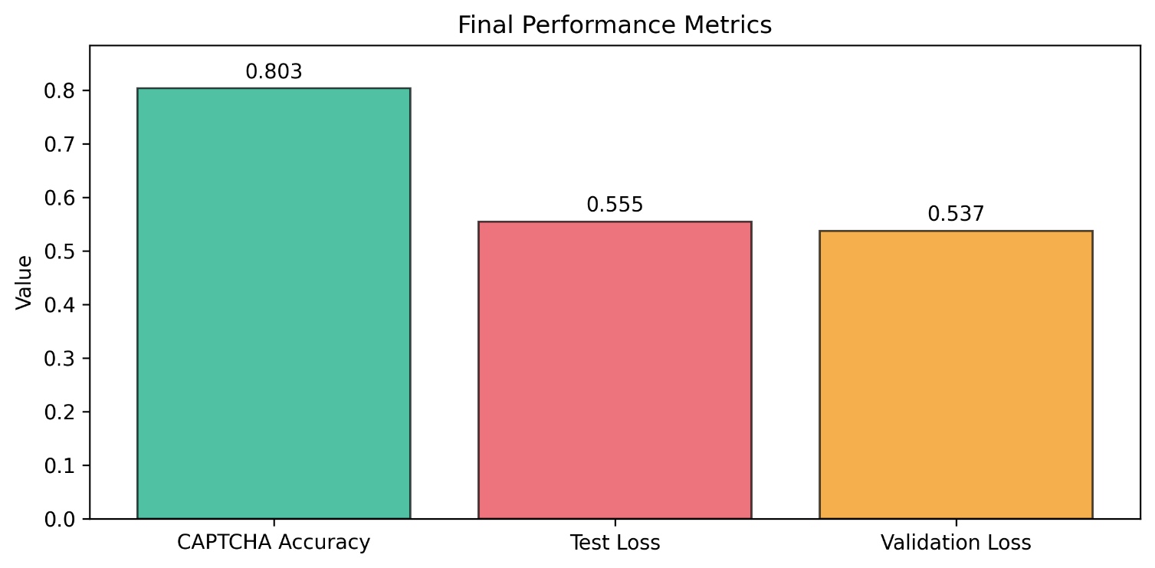
Figure 2: Bar Graph displaying the Final Performance Metrics of the model
Further insight into the optimisation dynamics during training is conveyed through the training and validation loss curves in Figure 3. The curves evidence a rapid decline in loss during the initial epochs, suggesting that the learning rate was well selected and the model focused on quickly learning the low-level features such as edges, straight-line segments, and curved strokes that are essentially needed to identify characters. After around ten epochs, the improvement rate reduced, and the curve started to stabilize. This change in gradient reflects a transition from learning simple patterns to refining more abstract features that distinguish among the sixty-two character classes. The training and validation curves remain smooth and monotonic throughout the training period. The absence of oscillation or divergence indicates that training was stable. The fact that the validation loss remains marginally lower than the training loss in the later epochs suggests that the data augmentation techniques and regularisation methods used during training produced more challenging examples in the training set than in the validation set. This behaviour reinforces the conclusion that the model’s learning is generalisable rather than specific to the training distribution.
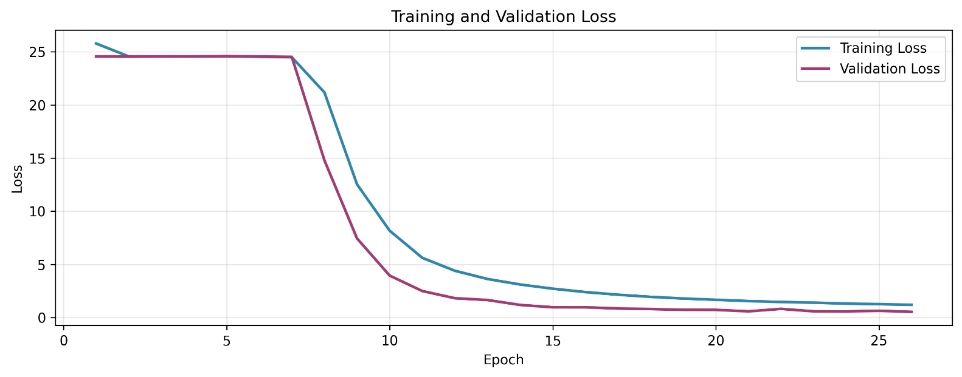
Figure 3: Line graph displaying the change in Training and Validation Losses over each Epoch
Character-level performance is further illustrated through the confusion matrix shown in Figure 4. The matrix displays a strong diagonal line of dark intensity, indicating high true positive rates across the full set of sixty-two character classes. The limited number of misclassifications off the diagonal demonstrates that errors are sparse and isolated rather than systematic. The majority of errors involve visually similar character pairs. The digit zero and the uppercase letter O are often confused when distortions blur the internal shape that distinguishes them. The digit one and the lowercase letter l are also occasionally confused when vertical compression or line occlusion removes the subtle height differences between these characters. These patterns reflect situations in which distortions or occluding artefacts obscure essential structural features. The confusion matrix therefore confirms that most misclassifications arise only when the underlying visual information has been heavily corrupted by CAPTCHA distortions.
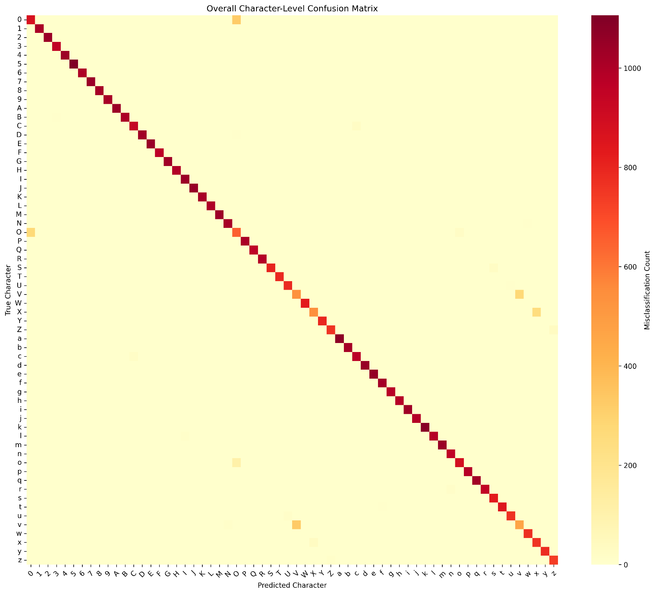
Figure 4: Confusion Matrix displaying the Model's misclassification count per character
The model’s positional consistency is illustrated in Figure 5, which presents the per-position accuracy across all six character positions. Accuracy remains above 95 percent for each position. This demonstrates that the model does not rely on positional cues or bias towards any segment of the CAPTCHA string. It also shows that character recognition remains stable across the entire spatial domain of the image. Since CAPTCHA generation systems frequently impose stronger distortions or increased overlap in specific positions within a string, it is important that the model can classify characters accurately regardless of their placement. The high positional accuracy therefore confirms that the convolutional filters successfully detect character features across a wide range of spatial conditions.
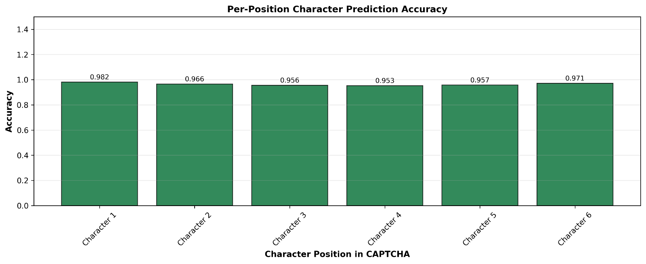
Figure 5: Bar Graph displaying Accuracy for each Character position in the CAPTCHAs
Figure 6 presents examples of correctly classified CAPTCHA images, which offer qualitative evidence of the model’s robustness. These examples show that the model can correctly recognise characters even when confronted with heavy background noise, severe curvature distortions, overlapping characters, and strong foreground occlusion lines. In these cases, the model correctly identifies each character despite the significant degradation of visual clarity. This capability reflects the effectiveness of the learned feature representations and the suitability of the convolutional layers for isolating informative visual patterns that remain constant even when distortions are applied.
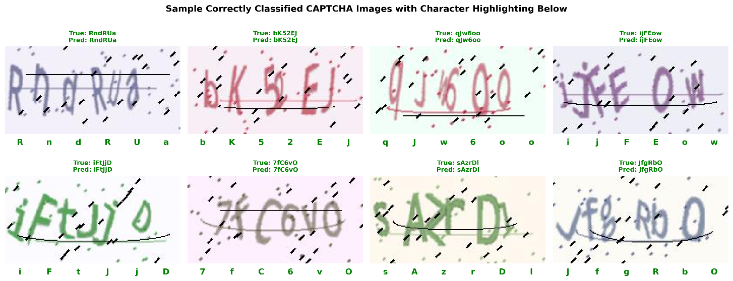
Figure 6: Sample Images of correctly predicted CAPTCHAS with Character Highlighting

Figure 7 provides examples of misclassified CAPTCHA images. These examples clearly indicate that such cases are close to the limits of distortion beyond which the model finds it difficult to identify the essential characters. Here, in one example, a thick interfering line masks the ascender of the lowercase d, imparting an appearance closer to that of a lowercase a. In other cases, character overlap merges two adjacent shapes into a single ambiguous form. Under such conditions the visual evidence required for correct classification is compromised. The misclassifications in Figure 7 therefore represent instances where the input image no longer contains sufficient structural information for accurate interpretation.
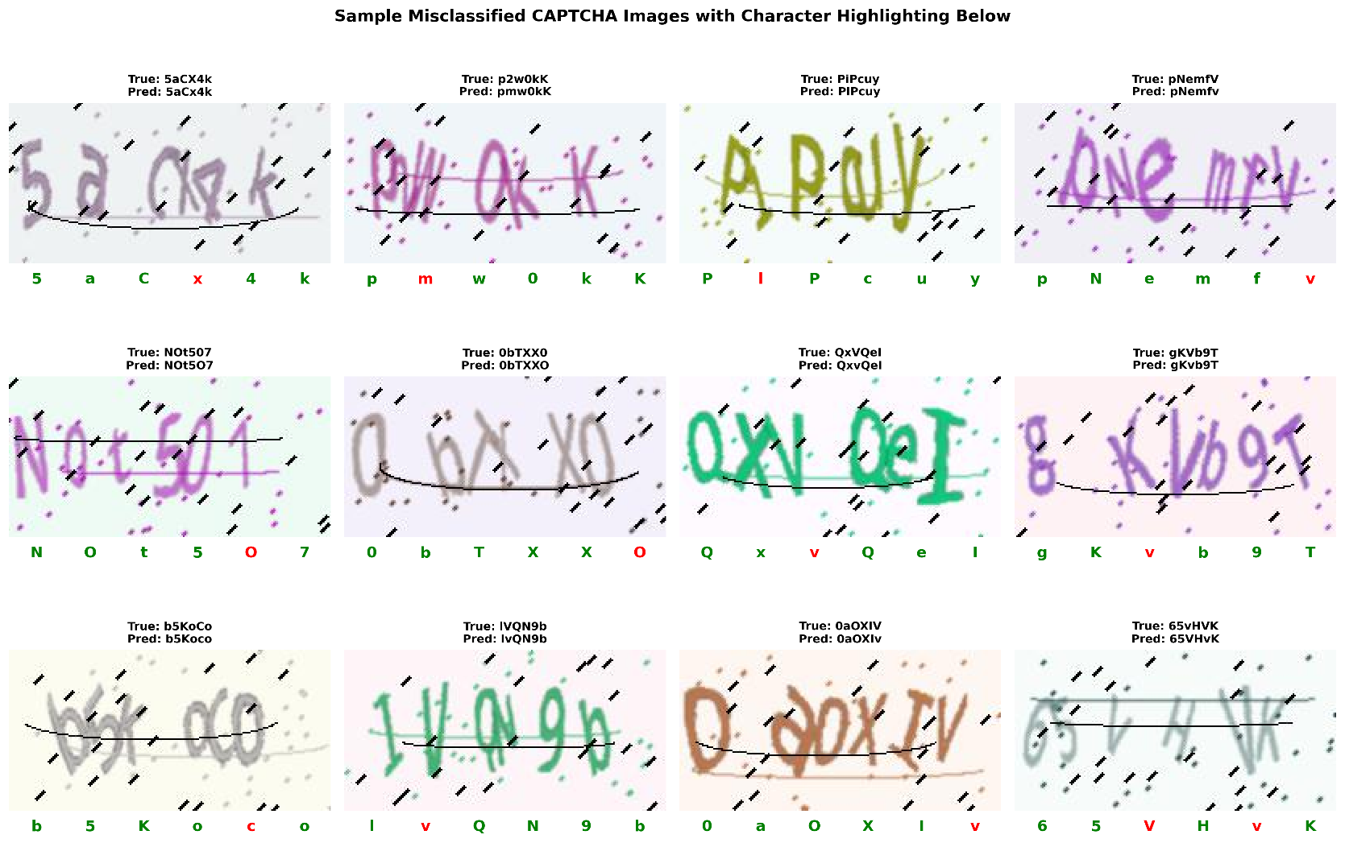
Figure 7: Sample Images of Incorrectly predicted CAPTCHAS with Character Highlighting

Report

Introduction
The procedure consisted of cleaning and preparing the data, exploratory data analysis, model construction, and comprehensive evaluation of a convolutional neural network developed for the classification of six-character CAPTCHA images (Goodfellow, Bengio and Courville, 2016). The aim of this section is to document the technical methods applied in the modelling process in order to provide detailed information on how the final model was created and validated (Lecun, Bengio and Hinton, 2015).
Data cleaning and preparation first involved the verification of image-label alignment, a procedure that ensured there were no corrupted or mismatched records within the dataset, as incorrect labels result in contradictory signals during training and performance degradation of the model (Frénay and Verleysen, 2014). Images were verified to be in their correct format and with the appropriate dimensions; any unreadable or malformed files were removed to prevent errors when training (Rawat and Wang, 2017). Labels were also checked for the presence of exactly six characters in each, reflecting the multi-output nature of the CAPTCHA recognition task (He and Garcia, 2009).
Then, pixel values had been normalized in the range between zero and one by division by 255. This is important for numerical stability and good gradient flow at the backpropagation step (Goodfellow, Bengio and Courville, 2016). Also, a histogram of pixel intensities had shown that raw values span over the whole range as expected, thus confirming the normalization step (Rawat and Wang, 2017). Further, the dataset was split into training, validation, and test sets using TensorFlow's Dataset API to enable coherent batching and minimal overhead while training (Goodfellow, Bengio and Courville, 2016).
To increase the diversity of training samples, automated augmentation was performed to preserve semantic integrity in labels. It exposes the model to more variants of distortions, occlusions, and noise, hence improving generalization with reduced overfitting (Shorten and Khoshgoftaar, 2019). Following cleaning and augmentation, the dataset was eminently suitable for training a convolutional neural network that could perform robust CAPTCHA recognition (Lecun, Bengio and Hinton, 2015).
Exploratory data analysis (EDA) was conducted to understand dataset complexity and structure. Qualitative examination of the example images showed the presence of varieties of distortion: rotation, non-linear warping, overlapped character images, and noisy backgrounds; thus, it called for deep convolutional feature extraction (Lecun, Bengio and Hinton, 2015; Rawat and Wang, 2017). Label distribution analysis indicated all sixty-two character classes were well represented, so there would be no need to use class balancing techniques (He and Garcia, 2009). Sequential structure checks confirmed that no position bias existed across six-character labels. Lastly, an examination of the augmented images showed transformations increased visual variety without affecting the semantic identity of the characters (Shorten and Khoshgoftaar, 2019).

Data Cleaning and Preparation
The input dataset included six character CAPTCHA images matched with their associated string labels. Before any modelling could occur, several data integrity checks were conducted to make sure that the images and labels aligned correctly, and that the dataset contained no corrupted records. The preprocessing pipeline first checked that all images were stored in the correct format and dimensions. Any images which could not be read or were incorrectly formatted were removed to prevent downstream errors. The label strings were also examined to ensure each contained exactly six characters, given that the task requires multi output prediction where each character position functions as an independent classification target. Any labels which did not match this requirement were excluded from the analysis.
Next, each image was normalised for numerical stability during training. The raw values were divided by two hundred and fifty-five to scale pixel values in the zero to one range. This rescaling ensured that all images contributed proportionally to the gradients during backpropagation, hence the convolutional layers learned meaningful patterns from the data efficiently (Goodfellow, Bengio and Courville, 2016). A histogram of pixel intensity distribution confirmed that the raw pixel values span across the full range from zero to two hundred and fifty-five; therefore, this step of scaling is in order. Finally, the training, validation, and test datasets were created using TensorFlow's Dataset pipeline for coherent splitting and effective batching at minimum possible overhead during training.
Another enhancement in data quality was automated augmentation. CAPTCHA text is purposefully distorted and irregular. Artificial augmentation was thus performed to increase the diversity of the training samples and enhance the strength of the model to generalise. This augmentation was set up to create new image variants through controlled random transformations that preserved correctness of labels while introducing more visual variability. This form of augmentation has been shown to improve deep learning model robustness by increasing sample diversity (Shorten and Khoshgoftaar, 2019). After cleaning and augmentation, therefore, the dataset was highly suitable for robust model training.

Exploratory Data Analysis
Before model selection or training, exploratory data analysis was carried out to investigate the structure and complexity of the CAPTCHA dataset. Since the dataset was image-based, visual inspection of representative samples served as the central exploratory technique. A grid of random CAPTCHA images is shown in Figure 8. There is great variation in distortions, including rotation, non-linear warping, occlusion by thick crossing lines, overlapping characters, and heavy background noise (Rawat and Wang, 2017). From these observations, it was confirmed that the task indeed required deep convolutional feature extraction, since traditional hand-engineered image processing approaches would not adequately address the variability and complexity built into the CAPTCHA system (Lecun, Bengio and Hinton, 2015).
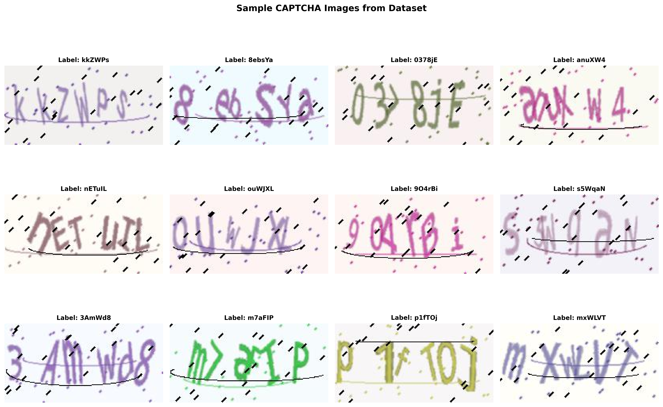
Figure 8: Sample of raw CAPTCHA Images
The distribution of true labels was also studied. A total of ten digits, twenty six lowercase letters and twenty six uppercase letters were used in the CAPTCHA system, which amounts to a total of sixty two classes. The outcome of label frequency analysis is presented in Figure 9 below, showing that the dataset was well balanced over all sixty two classes, where no single character dominates the dataset. This well-balanced dataset eliminated any need for class weighting, over-sampling, under-sampling strategies or any other balancing technique, ensuring the model encountered every type of character with sufficient frequency during training (He and Garcia, 2009). The sequential structure of the labels was analysed too, ensuring that no systematic positional bias existed across the six character positions.
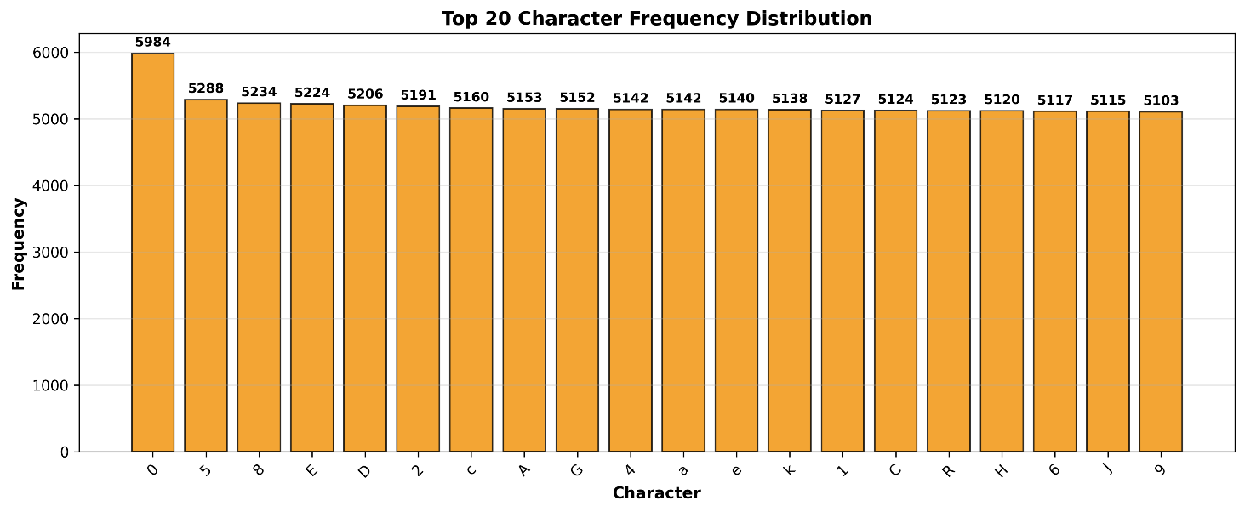
Figure 9: Bar Graph Displaying Character Frequency throughout dataset

Further exploratory analysis of the augmented images showed that these augmentation transformations maintained semantic integrity in the characters. All these transformations enhanced visual diversity without altering the essential identity of the characters (Shorten and Khoshgoftaar, 2019). Therefore, the exploration phase indeed provided necessary evidence that the dataset was suitable for a deep learning approach and that there was not any structural irregularity that could hamper the training process.

Model Training
This involved several stages of training the model: construction of the architecture, preparation of the dataset for fitting, and monitoring of training behaviour. The convolutional neural network was set up as a multi-output architecture that produced six predictions per image, corresponding to the six character positions. Each of the output heads applied a softmax activation function over sixty-two classes reflecting the class distribution identified in the exploratory analysis. It was compiled with categorical cross-entropy loss for each of the six output heads and overall accuracy as the main training metric. The Adam optimizer was chosen due to its adaptive learning rate capability, which enhances stability in training and accelerates convergence in image classification tasks (Kingma and Ba, 2014).
The cleaned and augmented dataset was fed into the model in shuffled batches to minimize memorisation and enhance generalisation across the training set. Training was performed over a large number of epochs with validation data provided at each epoch. Training and validation loss curves for Figure 3 demonstrated a steep drop in loss during the initial phase of training, thus demonstrating that the model learned crucial visual features quickly. These converged after around ten epochs, showing that an internal representation had been learnt which could tell the differences between the sixty-two classes with high accuracy (Lecun, Bengio and Hinton, 2015).
Care was taken during the training so that the losses of training and validation stay aligned, which shows that the network learned generalisable representations and did not over-fit to the training data (Frénay and Verleysen, 2014).

Model Evaluation
Quantitative metrics, character level analysis and qualitative review of predictions were used to assess the performance of the trained model. Overall CAPTCHA accuracy-which measures the proportion of six character strings predicted correctly-reached eighty point three percent on the unseen test dataset. This metric is of particular importance as it reflects complete sequence accuracy, which constitutes the need for all six characters to be correctly predicted for a CAPTCHA to be considered correct. The test loss with a value of zero point five aligned close enough to the validation loss at zero point five three seven to confirm that the model generalised effectively beyond the training distribution.
Training dynamics supported this outcome; there was a rapid decrease both in training and validation loss, which stabilized, hence the model learned the underlying structure of the distorted characters without overfitting (Goodfellow, Bengio and Courville, 2016).

Character-level performance was evaluated through the overall confusion matrix. The latter showed a strong diagonal, thus demonstrating proper classification across the sixty-two character classes. The misclassifications happened in cases of visual ambiguity-the digit zero being mistaken for the uppercase letter O, the digit one confused with the lowercase l. These reflected inherent visual ambiguities introduced by the CAPTCHA distortions rather than any flaws in model architecture (Rawat and Wang, 2017).
Position-based evaluation showed consistently high accuracy for all six character positions, all above ninety-five point five percent as depicted in Figure 5. This consistency demonstrated that the model did not rely on positional cues but instead learned spatially invariant character features (Lecun, Bengio and Hinton, 2015).
Further assessment using the receiver operating characteristic curve and the precision recall curve revealed that the model yielded a high discrimination ability while retaining high precision with increasing recall. These indeed confirmed that the model generated reliable probabilistic predictions across different decision thresholds. Qualitative examples of predictions demonstrated the pragmatic performance of the model. The correctly classified CAPTCHAs involved those with high distortion, overlapping characters, and heavy noise, thus illustrating the robustness of the learned feature representations. Misclassified examples revealed instances of extreme occlusion where essential visual information was removed, making the characters indistinguishable even to a human observer.

Conclusion
This is further reinforced by the structured workflow of cleaning, augmentation, exploratory analysis, model construction, and evaluation because such steps ensure that a convolutional neural network is trained on a high-quality and representative dataset (Goodfellow, Bengio and Courville, 2016). Normalization and augmentation contribute to numerical stability and generalization to improve model performance, thus enabling it to learn spatially invariant features across all character positions (Shorten and Khoshgoftaar, 2019).
In fact, EDA showed that the dataset was well balanced across all classes and had enough variability to train a deep learning model on handling distortions and noise (He and Garcia, 2009; Rawat and Wang, 2017). Training of the model could be rapidly converged with high accuracy and with minimal overfitting using the Adam optimizer and an architecture with carefully chosen parameters (Kingma and Ba, 2014; Lecun, Bengio and Hinton, 2015).
Evaluation metrics were very strong, confirming that most misclassifications in character confusion matrices were due to intrinsic visual ambiguities rather than architectural flaws (Rawat and Wang, 2017). Position-based accuracy demonstrated a consistent performance for the six-character outputs, confirming that there was generalization of spatial features by the model (Lecun, Bengio and Hinton, 2015).

Reference List
Frénay, B. and Verleysen, M., 2014. Classification in the presence of label noise: A survey. IEEE Transactions on Neural Networks and Learning Systems, 25(5), pp.845–869. https://doi.org/10.1109/TNNLS.2013.2292894.
Goodfellow, I., Bengio, Y. and Courville, A., 2016. Deep Learning. [online] pp.1–23. Available at: <https://mitpress.mit.edu/9780262035613/deep-learning/> [Accessed 17 May 2025].
He, H. and Garcia, E.A., 2009. Learning from imbalanced data. IEEE Transactions on Knowledge and Data Engineering, [online] 21(9), pp.1263–1284. https://doi.org/10.1109/TKDE.2008.239.
Kingma, D.P. and Ba, J.L., 2014. Adam: A Method for Stochastic Optimization. 3rd International Conference on Learning Representations, ICLR 2015 - Conference Track Proceedings. [online] Available at: <https://arxiv.org/pdf/1412.6980> [Accessed 21 November 2025].
Krizhevsky, A., Sutskever, I. and Hinton, G.E., 2012. ImageNet Classification with Deep Convolutional Neural Networks. [online] Available at: <http://code.google.com/p/cuda-convnet/>.
Lecun, Y., Bengio, Y. and Hinton, G., 2015. Deep learning. Nature, https://doi.org/10.1038/nature14539.
Rawat, W. and Wang, Z., 2017. Deep Convolutional Neural Networks for Image Classification: A Comprehensive Review. Neural computation, [online] 29(9), pp.2352–2449. https://doi.org/10.1162/NECO_A_00990.
Segovia, J., 2016. Breaking captchas from scratch (almost). [online] Available at: <https://medium.com/lemontech-engineering/breaking-captchas-from-scracth-almost-753895fade8a> [Accessed 21 November 2025].
Shorten, C. and Khoshgoftaar, T.M., 2019. A survey on Image Data Augmentation for Deep Learning. Journal of Big Data 2019 6:1, [online] 6(1), pp.60-. https://doi.org/10.1186/S40537-019-0197-0.
Srivastava, N., Hinton, G., Krizhevsky, A. and Salakhutdinov, R., 2014. Dropout: A Simple Way to Prevent Neural Networks from Overfitting. Journal of Machine Learning Research, .
Sun, C., Shrivastava, A., Singh, S. and Gupta, A., 2017. Revisiting Unreasonable Effectiveness of Data in Deep Learning Era. Proceedings of the IEEE International Conference on Computer Vision, [online] 2017-October, pp.843–852. https://doi.org/10.1109/ICCV.2017.97.

